**TOPIC:- Spring-rest-handson**

**Q) Hello World RESTful Web Service**   
  
Write a REST service in the spring learn application created earlier, that returns the text "Hello World!!" using Spring Web Framework. Refer details below:  
  
**Method:** GET  
**URL:** /hello  
**Controller:** com.cognizant.spring-learn.controller.HelloController  
**Method Signature:** public String sayHello()  
**Method Implementation:** return hard coded string "Hello World!!"  
**Sample Request**: http://localhost:8083/hello  
**Sample Response:** Hello World!!   
  
**IMPORTANT NOTE**: Don't forget to include start and end log in the sayHello() method.

Try the URL http://localhost:8083/hello in both chrome browser and postman.

SME to explain the following aspects:

* In network tab of developer tools show the HTTP header details received
* In postman click on "Headers" tab to view the HTTP header details received

**Solution**

**Code:-**

**pom.xml**

<?xml version="1.0" encoding="UTF-8"?>

<project xmlns="http://maven.apache.org/POM/4.0.0" xmlns:xsi="http://www.w3.org/2001/XMLSchema-instance"

xsi:schemaLocation="http://maven.apache.org/POM/4.0.0 https://maven.apache.org/xsd/maven-4.0.0.xsd">

<modelVersion>4.0.0</modelVersion>

<parent>

<groupId>org.springframework.boot</groupId>

<artifactId>spring-boot-starter-parent</artifactId>

<version>3.5.3</version>

<relativePath/> <!-- lookup parent from repository -->

</parent>

<groupId>com.cognizant.springlearn</groupId>

<artifactId>HelloWorld_RESTfulWebService</artifactId>

<version>0.0.1-SNAPSHOT</version>

<name>Hello World RESTful Web Service</name>

<description>Demo project for Spring REST</description>

<url/>

<licenses>

<license/>

</licenses>

<developers>

<developer/>

</developers>

<scm>

<connection/>

<developerConnection/>

<tag/>

<url/>

</scm>

<properties>

<java.version>21</java.version>

</properties>

<dependencies>

<dependency>

<groupId>org.springframework.boot</groupId>

<artifactId>spring-boot-starter-web</artifactId>

</dependency>

<dependency>

<groupId>org.springframework.boot</groupId>

<artifactId>spring-boot-starter-test</artifactId>

<scope>test</scope>

</dependency>

</dependencies>

<build>

<plugins>

<plugin>

<groupId>org.springframework.boot</groupId>

<artifactId>spring-boot-maven-plugin</artifactId>

</plugin>

</plugins>

</build>

</project>

**application.properties**

spring.application.name=Hello World RESTful Web Service

server.port=8083

**HelloController.java**

package com.cognizant.springlearn.controller;

import org.slf4j.Logger;

import org.slf4j.LoggerFactory;

import org.springframework.web.bind.annotation.GetMapping;

import org.springframework.web.bind.annotation.RequestMapping;

import org.springframework.web.bind.annotation.RestController;

@RestController

@RequestMapping("/hello")

public class HelloController {

private static final Logger LOGGER = LoggerFactory.getLogger(HelloController.class);

@GetMapping

public String sayHello() {

LOGGER.info("Start of sayHello method");

String response = "Hello World!!";

LOGGER.info("End of sayHello method");

return response;

}

}

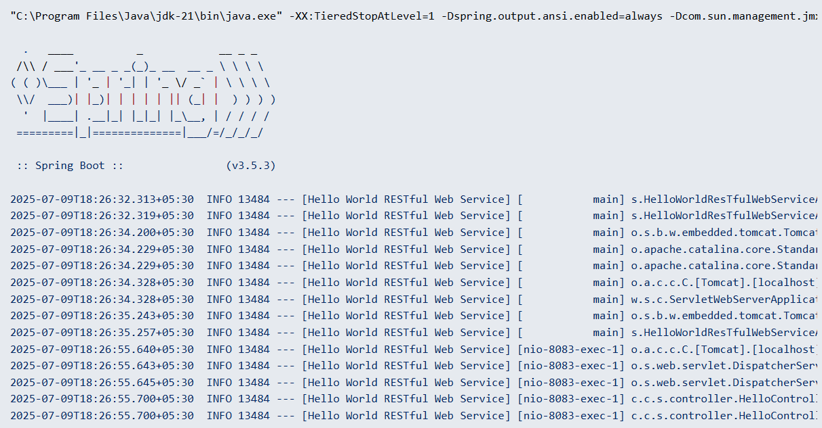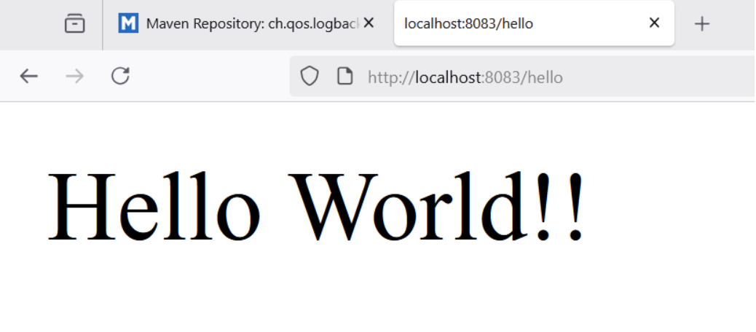**OUTPUT :-**

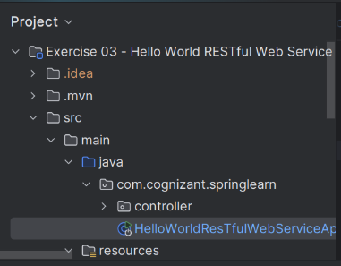

**Q) REST - Country Web Service**Write a REST service that returns India country details in the earlier created spring learn application.  
  
URL: /country  
Controller: com.cognizant.spring-learn.controller.CountryController  
Method Annotation: @RequestMapping  
Method Name: getCountryIndia()  
Method Implementation: Load India bean from spring xml configuration and return  
Sample Request: http://localhost:8083/country  
Sample Response:

{

  "code": "IN",

  "name": "India"

}

**pom.xml**

<?xml version="1.0" encoding="UTF-8"?>

<project xmlns="http://maven.apache.org/POM/4.0.0"

xmlns:xsi="http://www.w3.org/2001/XMLSchema-instance"

xsi:schemaLocation="http://maven.apache.org/POM/4.0.0 http://maven.apache.org/xsd/maven-4.0.0.xsd">

<modelVersion>4.0.0</modelVersion>

<groupId>com.cognizant</groupId>

<artifactId>spring-learn</artifactId>

<version>0.0.1-SNAPSHOT</version>

<name>RestCountryWebService</name>

<description>REST Country Web Service</description>

<parent>

<groupId>org.springframework.boot</groupId>

<artifactId>spring-boot-starter-parent</artifactId>

<version>3.5.3</version>

<relativePath/>

</parent>

<properties>

<java.version>21</java.version>

<maven.compiler.source>21</maven.compiler.source>

<maven.compiler.target>21</maven.compiler.target>

<project.build.sourceEncoding>UTF-8</project.build.sourceEncoding>

</properties>

<dependencies>

<dependency>

<groupId>org.springframework.boot</groupId>

<artifactId>spring-boot-starter-web</artifactId>

</dependency>

<dependency>

<groupId>org.springframework</groupId>

<artifactId>spring-context</artifactId>

</dependency>

</dependencies>

<build>

<plugins>

<plugin>

<groupId>org.springframework.boot</groupId>

<artifactId>spring-boot-maven-plugin</artifactId>

</plugin>

</plugins>

</build>

</project>

**Country.java – Model Class**

package com.cognizant.springlearn.model;

public class Country {

private String code;

private String name;

public Country() {

}

public Country(String code, String name) {

this.code = code;

this.name = name;

}

public String getCode() {

return code;

}

public void setCode(String code) {

this.code = code;

}

public String getName() {

return name;

}

public void setName(String name) {

this.name = name;

}

}

**applicationContext.xml**

<?xml version="1.0" encoding="UTF-8"?>

<beans xmlns="http://www.springframework.org/schema/beans"

xmlns:xsi="http://www.w3.org/2001/XMLSchema-instance"

xsi:schemaLocation="http://www.springframework.org/schema/beans

http://www.springframework.org/schema/beans/spring-beans.xsd">

<bean id="india" class="com.cognizant.springlearn.model.Country">

<property name="code" value="IN"/>

<property name="name" value="India"/>

</bean>

</beans>

**CountryController.java**

package com.cognizant.springlearn.controller;

import com.cognizant.springlearn.model.Country;

import org.springframework.beans.factory.annotation.Autowired;

import org.springframework.beans.factory.annotation.Qualifier;

import org.springframework.web.bind.annotation.RequestMapping;

import org.springframework.web.bind.annotation.RestController;

@RestController

public class CountryController {

@Autowired

@Qualifier("india")

private Country country;

@RequestMapping("/country")

public Country getCountryIndia() {

return country;

}

}

**RestCountryWebServiceApplication.java**

package com.cognizant.springlearn;

import org.springframework.boot.SpringApplication;

import org.springframework.boot.autoconfigure.SpringBootApplication;

import org.springframework.context.annotation.ImportResource;

@SpringBootApplication

@ImportResource("classpath:applicationContext.xml")

public class RestCountryWebServiceApplication {

public static void main(String[] args) {

SpringApplication.run(RestCountryWebServiceApplication.class, args);

}

}

**application.properties**

server.port=8083

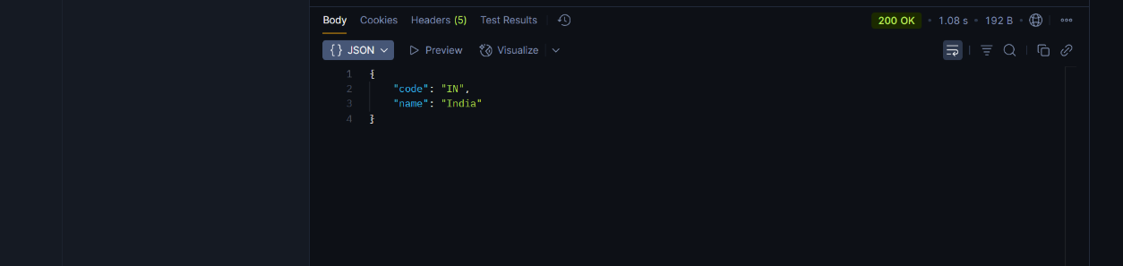**OUTPUT:-**

**Q) REST - Get country based on country code**   
  
Write a REST service that returns a specific country based on country code. The country code should be case insensitive.  
  
**Controller**: com.cognizant.spring-learn.controller.CountryController  
**Method Annotation:** @GetMapping("/countries/{code}")  
**Method Name**: getCountry(String code)  
**Method Implemetation**: Invoke countryService.getCountry(code)   
**Service Method:**com.cognizant.spring-learn.service.CountryService.getCountry(String code)  
  
**Service Method Implementation**:

* Get the country code using @PathVariable
* Get country list from country.xml
* Iterate through the country list
* Make a case insensitive matching of country code and return the country.
* Lambda expression can also be used instead of iterating the country list

**Sample Request**: http://localhost:8083/country/in  
  
**Sample Response**:

{

  "code": "IN",

  "name": "India"

}

**pom.xml**

<?xml version="1.0" encoding="UTF-8"?>

<project xmlns="http://maven.apache.org/POM/4.0.0" xmlns:xsi="http://www.w3.org/2001/XMLSchema-instance"

xsi:schemaLocation="http://maven.apache.org/POM/4.0.0 https://maven.apache.org/xsd/maven-4.0.0.xsd">

<modelVersion>4.0.0</modelVersion>

<parent>

<groupId>org.springframework.boot</groupId>

<artifactId>spring-boot-starter-parent</artifactId>

<version>3.5.3</version>

<relativePath/> <!-- lookup parent from repository -->

</parent>

<groupId>om.cognizant.spring-learn</groupId>

<artifactId>spring-learn</artifactId>

<version>0.0.1-SNAPSHOT</version>

<name>spring-learn</name>

<description>Demo project for Spring Boot</description>

<url/>

<licenses>

<license/>

</licenses>

<developers>

<developer/>

</developers>

<scm>

<connection/>

<developerConnection/>

<tag/>

<url/>

</scm>

<properties>

<java.version>17</java.version>

</properties>

<dependencies>

<dependency>

<groupId>org.springframework.boot</groupId>

<artifactId>spring-boot-starter-web</artifactId>

</dependency>

<dependency>

<groupId>org.springframework.boot</groupId>

<artifactId>spring-boot-devtools</artifactId>

<scope>runtime</scope>

<optional>true</optional>

</dependency>

<dependency>

<groupId>org.springframework.boot</groupId>

<artifactId>spring-boot-starter-test</artifactId>

<scope>test</scope>

</dependency>

<!-- https://mvnrepository.com/artifact/javax.xml.bind/jaxb-api -->

<dependency>

<groupId>javax.xml.bind</groupId>

<artifactId>jaxb-api</artifactId>

<version>2.3.1</version>

</dependency>

<dependency>

<groupId>org.glassfish.jaxb</groupId>

<artifactId>jaxb-runtime</artifactId>

<version>2.3.5</version>

</dependency>

<dependency>

<groupId>jakarta.annotation</groupId>

<artifactId>jakarta.annotation-api</artifactId>

<version>2.1.1</version>

</dependency>

</dependencies>

<build>

<plugins>

<plugin>

<groupId>org.springframework.boot</groupId>

<artifactId>spring-boot-maven-plugin</artifactId>

</plugin>

</plugins>

</build>

</project>

**countries.xml**

<?xml version="1.0" encoding="UTF-8"?>

<countries>

<country>

<code>IN</code>

<name>India</name>

</country>

<country>

<code>US</code>

<name>United States</name>

</country>

<country>

<code>DE</code>

<name>Germany</name>

</country>

<country>

<code>JP</code>

<name>Japan</name>

</country>

</countries>

**Country.java**

package com.cognizant.spring_learn.model;

import javax.xml.bind.annotation.XmlRootElement;

@XmlRootElement(name = "country")

public class Country {

private String code;

private String name;

public Country() {}

public Country(String code, String name) {

this.code = code;

this.name = name;

}

public String getCode() {

return code;

}

public void setCode(String code) {

this.code = code.toUpperCase(); // Following convention

}

public String getName() {

return name;

}

public void setName(String name) {

this.name = name;

}

}

**CountryList.java**

package com.cognizant.spring_learn.model;

import javax.xml.bind.annotation.XmlElement;

import javax.xml.bind.annotation.XmlRootElement;

import java.util.List;

@XmlRootElement(name = "countries")

public class CountryList {

private List<Country> countries;

@XmlElement(name = "country")

public List<Country> getCountries() {

return countries;

}

public void setCountries(List<Country> countries) {

this.countries = countries;

}

}

**CountryService.java**

package com.cognizant.spring_learn.service;

import com.cognizant.spring_learn.model.Country;

import com.cognizant.spring_learn.model.CountryList;

import org.springframework.http.HttpStatus;

import org.springframework.stereotype.Service;

import jakarta.annotation.PostConstruct;

import org.springframework.web.server.ResponseStatusException;

import javax.xml.bind.JAXBContext;

import javax.xml.bind.Unmarshaller;

import java.io.InputStream;

import java.util.List;

@Service

public class CountryService {

private List<Country> countries;

@PostConstruct

public void init() throws Exception {

InputStream is = getClass().getClassLoader().getResourceAsStream("country.xml");

JAXBContext context = JAXBContext.newInstance(CountryList.class);

Unmarshaller unmarshaller = context.createUnmarshaller();

CountryList countryList = (CountryList) unmarshaller.unmarshal(is);

this.countries = countryList.getCountries();

}

public Country getCountry(String code) throws Exception {

for(Country con : countries){

if (con.getCode().equalsIgnoreCase(code)) {

return con;

}

}

throw new ResponseStatusException(HttpStatus.NOT_FOUND, "Country not found for country code: " + code);

}

}

**CoutryController.java**

package com.cognizant.spring_learn.controller;

import com.cognizant.spring_learn.model.Country;

import com.cognizant.spring_learn.service.CountryService;

import org.springframework.beans.factory.annotation.Autowired;

import org.springframework.web.bind.annotation.*;

@RestController

public class CountryController {

@Autowired

private CountryService countryService;

@GetMapping("/countries/{code}")

public Country getCountry(@PathVariable String code) throws Exception {

return countryService.getCountry(code);

}

}

**SpringLearnApplication.java**

package com.cognizant.spring_learn;

import org.springframework.boot.SpringApplication;

import org.springframework.boot.autoconfigure.SpringBootApplication;

@SpringBootApplication

public class SpringLearnApplication {

public static void main(String[] args) {

SpringApplication.run(SpringLearnApplication.class, args);

}

}

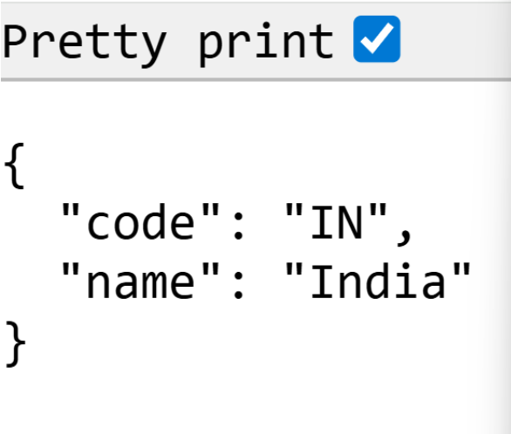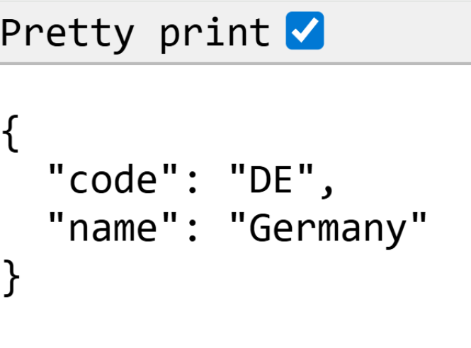**OUTPUT:-**